ACTH short notes
- We decided to only include the regulatory secretory pathway as the process by which POMC is exported from the Golgi apparatus and not the conventional pathways since this one did not include ACTH synthesis.
- No specific information about the transport of proopiomelanocortin to the ER by SRP was found. We assumed that this was a general pathway for many secretory proteins, which is the case for POMC and therefore we included it.
- For the GPR rules of the SRP enzyme it is unclear whether SRP68 and SRP72 have to be both present in order for it to work as the image suggests either of them can be present. This is also observed in SRP9 and SRP14. 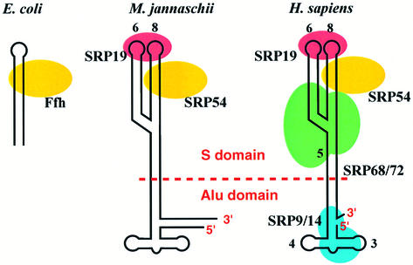
From: NEW EMBO MEMBER’S REVIEW: Structure, function and evolution of the signal recognition particle - PMC

- Unsure whether we should include the regulation of misfolding of POMC in the task. We added more information, as well as, reactions below (see information below (a)).
- There was no specific information on PDI and ERO1 being involved in the disulfide processing of POMC. However, we still added it as this process is generally mediated by PDI and ERO1.
- Unsure whether POMC undergoes isomerization in the ER after folding, as no information was found and this is a process that usually occurs.
- Found information about post translational modifications occurring. However, these do not seem to be involved in the task since we only found literature of glycosylation occurring to other products of POMC that are not ACTH (see information below (b)).
- No specific information on how POMC goes from the ER to the Golgi apparatus. However, since this process seems to be common for most prohormones, we included it. (COPI and COPII)
- We are not sure if MIA2 is involved in the inner coat of COPII, since in literature concerning proinsulin it mentions its presence however when searching the MIA2 in gene cards it mentions that it is used for larger cargo that does not fit into COPII-coated vesicles (see references below (c)).
- Unsure if we should add further cleavage of ACTH and other products of POMC since our hormone of interest is ACTH, therefore it does not seem relevant for the task as ACTH has already been synthesised (see references below (d)).
- For the reaction where POMC binds to the SRP receptor and the translocon in order to enter the ER, we divided this reaction into 2:
SRP receptor and SEC61:
Reaction 1: pre-pro-opiomelanocortin-2-SRP[r] + GTP → pre-pro-opiomelanocortin-2-SRP[t] + GDP
Reaction 2: pre-pro-opiomelanocortin-2-SRP[t] → pre-pro-opiomelanocortin-2-SRP[er]
GPR: (SRPRA AND SRPRB) AND ((Sec61A OR SEC61A2) AND SEC61B AND SEC61G)

We divided the sorting of POMC from the Golgi Apparatus into granules in different steps and reactions. 1. Aggregation of POMC, 2. Formation of membrane-bound aggregates (binding to CPE), 3. Formation and coating of immature granules, 4. Acidification/maturation of granules.
- Id not add AP3G1 to the GPR rule involved in clathrin coating of granules due to its absence in ensembl.
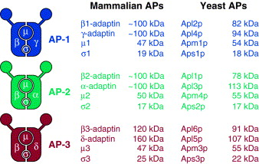
From: The AP-3 complex: a coat of many colours - ScienceDirect

Regulation of misfolding in the ER

ER-associated degradation (ERAD) (Sel1L-Hrd1 complex)
Misfolded proteins in the ER are generally removed by ERAD, which includes the Sel1L-Hrd1 complex. 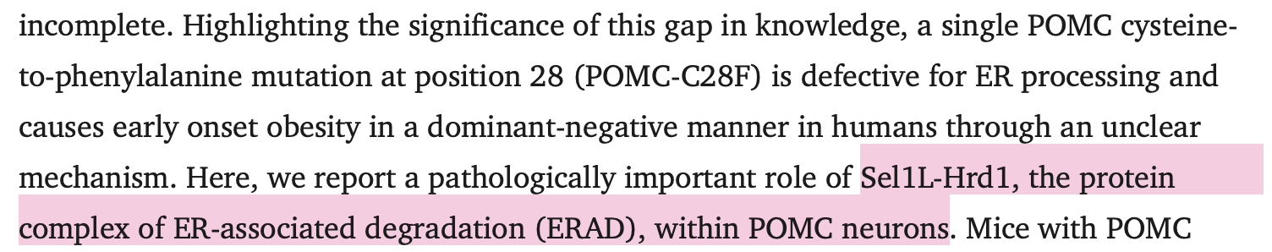
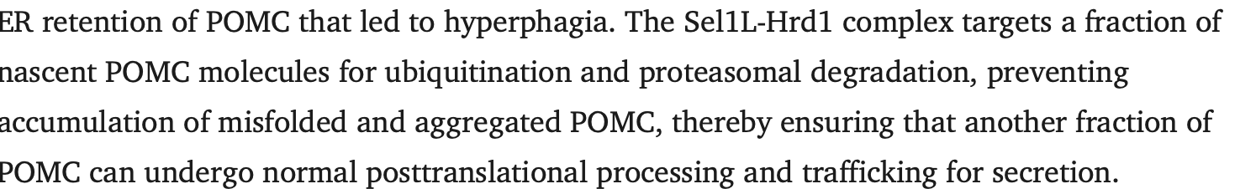
From: https://pmc.ncbi.nlm.nih.gov/articles/PMC5824855/

This complex works by detecting misfolded proteins with lectins like, OS9 OR ERLEC1, then retrotranslocating them across the ER membrane by HRD1 and, tagging them with ubiquitin with HRD1 and the the polyubiquitinated substrates are extracted by the AAA+-ATPase VCP/p97/Cdc48; Finally, they are degraded by a proteasome, 26S proteasome.
​​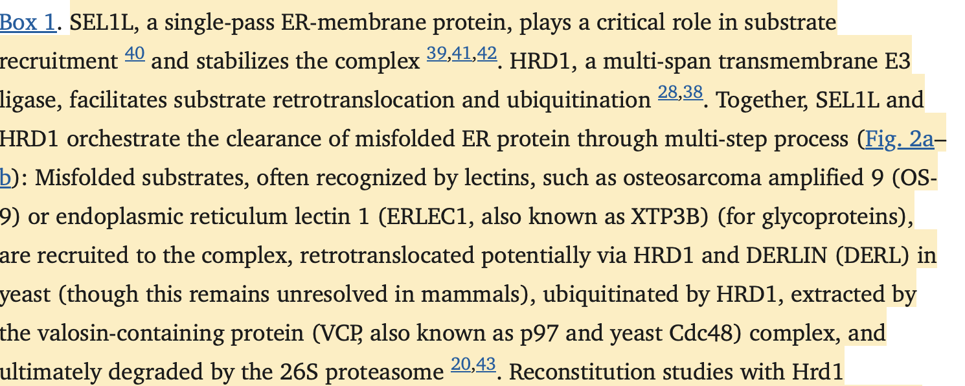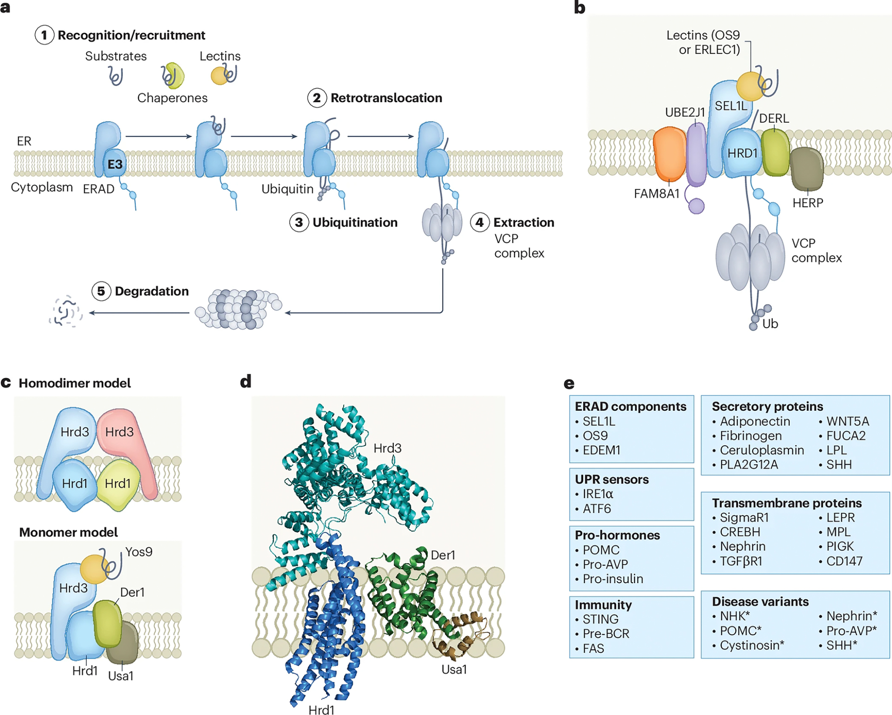
(b) Schematic illustration of the mammalian SEL1L-HRD1 core complex and associated cofactors including OS9 and ERLEC1 (substrate adaptors), DERL (retrotranslocation facilitators), HERP1 and FAM8A1 (regulatory components), the E2 ubiquitin-conjugating enzyme UBE2J1, and AAA +-ATPase valosin-containing protein VCP/p97/Cdc48 complex
From: https://pmc.ncbi.nlm.nih.gov/articles/PMC12392366/#:~:text=SEL1L%2C%20a%20single%2Dpass%20ER,subject%20of%20debate%2045%2C46.

Gene | ENSEMBL id |  | Main transcript |  | Link
SEL1L | ENSG00000071537 |  | ENST00000336735, ENSP00000337053 |  | https://www.ensembl.org/Homo_sapiens/Gene/Summary?db=core;g=ENSG00000071537;r=14:81471547-81533863
HRD1 | No data found |  | No data found |  | No data found
OS9 | ENSG00000135506 | ENST00000315970, ENSP00000318165 |  | Gene: OS9 (ENSG00000135506) - Summary - Homo_sapiens - Ensembl genome browser 115
ERLEC1 | ENSG00000068912 | ENST00000185150, ENSP00000185150 |  | Gene: ERLEC1 (ENSG00000068912) - Summary - Homo_sapiens - Ensembl genome browser 115
VCP | ENSG00000165280 | ENST00000358901, ENSP00000351777 |  | Gene: VCP (ENSG00000165280) - Summary - Homo_sapiens - Ensembl genome browser 115
HEY2  (HERP1) | ENSG00000135547 | ENST00000368364, ENSP00000357348 |  | Gene: HEY2 (ENSG00000135547) - Summary - Homo_sapiens - Ensembl genome browser 115
FAM8A1 | ENSG00000137414 | ENST00000259963, ENSP00000259963 |  | Gene: FAM8A1 (ENSG00000137414) - Summary - Homo_sapiens - Ensembl genome browser 115
UBE2J1 | ENSG00000198833 | ENST00000435041, ENSP00000451261 |  | Gene: UBE2J1 (ENSG00000198833) - Summary - Homo_sapiens - Ensembl genome browser 115

GPR rules:
Reaction: misfolded POMC → degraded POMC
GPR: (OS9 OR ERLEC1) AND SEL1L AND HRD1 AND VCP AND HERP1 AND FAM8A1 AND UBEJ2J

RTN3:
From: PGRMC1 acts as a size-selective cargo receptor to drive ER-phagic clearance of mutant prohormones | Nature Communications
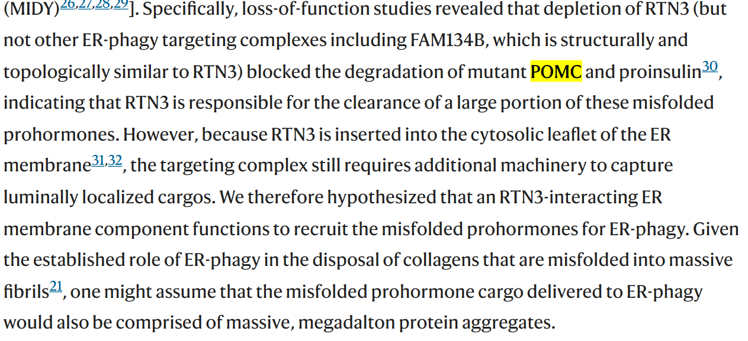
The misfolded POMC is currently located in the ER lumen, while the RTN3 is located outside. PGRMC1 is a transmembrane protein that recognises misfolded POMC and binds to it. Once this happens, PGRMC1 also binds to RTN3, forming a PGRMC1-RTN3 complex. RTN3 allows the formation of an autophagosome around the misfolded POMC, which leaves the ER and is delivered to the lysosome where the misfolded POMC is destroyed.

Gene | ENSEMBL id |  | Main transcript
PGRMC1 | ENSG00000101856 | ENST00000217971, ENSP00000217971 |  | Gene: PGRMC1 (ENSG00000101856) - Summary - Homo_sapiens - Ensembl genome browser 115
RTN3 | ENSG00000133318 | ENST00000377819, ENSP00000367050 |  | Gene: RTN3 (ENSG00000133318) - Summary - Homo_sapiens - Ensembl genome browser 115

GPR rules:
Reaction: misfolded POMC → Degraded POMC
GPR: PGRMC1 AND RTN3

Information on PTMs
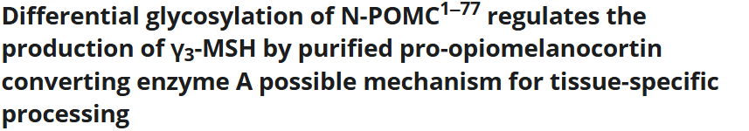
From: Differential glycosylation of N‐POMC1–77 regulates the production of γ3‐MSH by purified pro‐opiomelanocortin converting enzyme A possible mechanism for tissue‐specific processing - Birch - 1991 - FEBS Letters - Wiley Online Library

Glycosylation:
In addition to cleavage, POMC and POMC-derived peptides undergo several posttranslational modifications such as acetylation, amidation, phosphorylation, glycosylation, and disulfide linkage formation. Therefore, the POMC system is undoubtedly multifunctional, i.e., in addition to the generation of several peptides, various modifications could diversify the biological functions of POMC-derived peptides.
Posttranslational modification sometimes alters either the binding affinity between the hormonal peptides and their receptors, or the downstream intracellular signal transduction. It is thought that the complex POMC network is made up of a variety of peptides with additional modifications and receptor subtypes distributed in many different tissues and organs. Therefore, POMC could be a useful model for investigating posttranslational modifications in endocrine systems.
From: https://www.frontiersin.org/journals/endocrinology/articles/10.3389/fendo.2013.00143/full

Acetylation:
Acetylation of the N-termini of Des-Ac-α-MSH and β-END, phosphorylation of ACTH, and glycosylation of N-POMC are the representative posttranslational modifications of POMC or POMC-derived peptides (2–4). Acetylation is known to affect the biological function of POMC-derived peptides (10). Between the two lobes in which POMC is generated, acetylation frequently occurs in the PI.
From: https://www.frontiersin.org/journals/endocrinology/articles/10.3389/fendo.2013.00143/full

Presence of MIA2 in the inner coat of COPII:
We are not sure if MIA2 is involved in the inner coat of COPII , since in literature concerning proinsulin it mentions its presence however when searching the MIA2 in gene cards it mentions that it is used for larger cargo that does not fit into COPII-coated vesicles.

From: MIA2 Gene - GeneCards | MIA2 Protein | MIA2 Antibody

Further cleavage of ACTH:
ACTH is further cleaved by PC2 into ACTH (1-17) and corticotropin like intermediate peptide (CLIP) 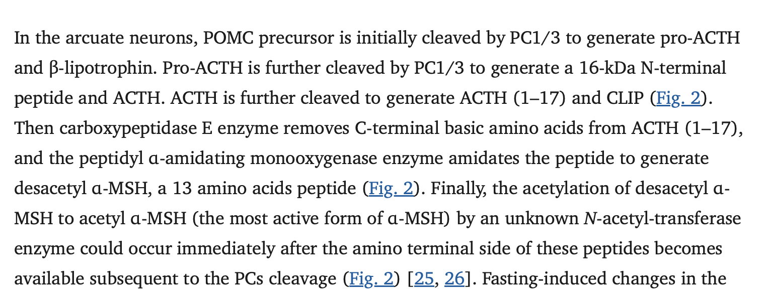
From: https://pmc.ncbi.nlm.nih.gov/articles/PMC3936413/

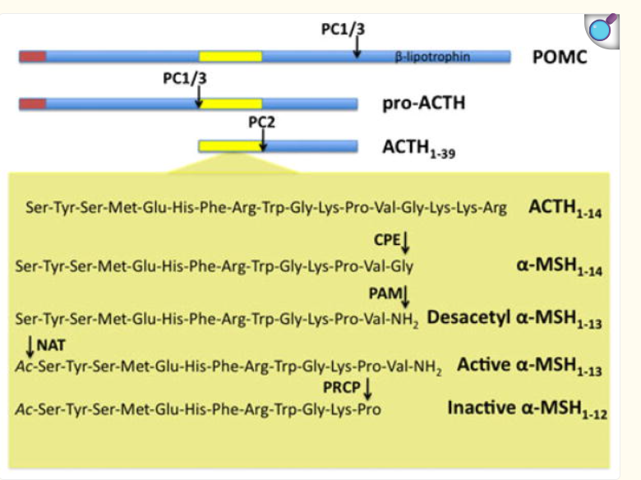
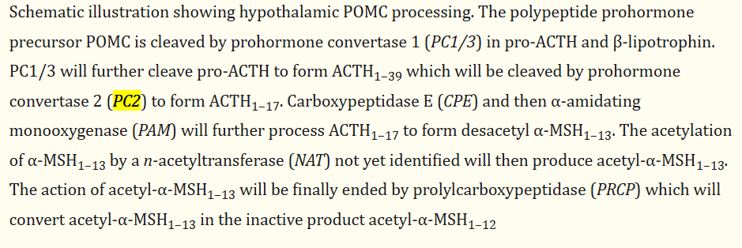
From: alpha-Melanocyte stimulating hormone: production and degradation - PMC

Gene name | ENSEMBL id | Main transcript | Link
PCSK2 (PC2) | ENSG00000125851 | ENST00000262545.7 | https://www.ensembl.org/Homo_sapiens/Gene/Summary?db=core;g=ENSG00000125851;r=20:17226107-17484578

Cleavage ACTH:
Reaction: ACTH → ACTH (1-17) + CLIP
GPR: PCK2

Then ACTH (1-17) is cleaved by CPE, which will remove the C-terminal basic amino acids and further processed by PAM forming alpha-MSH (1-13).

Gene name | ENSEMBL id | Main transcript | Link
CPE | ENSG00000109472 | ENST00000402744, ENSP00000386104 | Gene: CPE (ENSG00000109472) - Summary - Homo_sapiens - Ensembl genome browser 115
PAM | ENSG00000145730 | ENST00000438793, ENSP00000396493 | Gene: PAM (ENSG00000145730) - Summary - Homo_sapiens - Ensembl genome browser 115

Cleavage ACTH (1-17):
Reaction: ACTH (1-17) → alpha-MSH (1-13)
GPR: CPE AND PAM

Later, alpha-MSH will be acetylated by NAT which will rise to acetyl-alpha-MSH (1-13).

Acetylation of alpha-MSH
Reaction: N-acetyltransferase + alpha-MSH (1-13) → acetyl-alpha-MSH(1-13)

Finally PRCP will convert acetyl-alpha-MSH(1-13) into the inactive product, acetyl-alpha-MSH(1-12).

Gene name | ENSEMBL id | Main transcript | Link
PRCP | ENSG00000137509 | ​ENST00000313010, ENSP00000317362 | https://www.ensembl.org/Homo_sapiens/Gene/Summary?db=core;g=ENSG00000137509;r=11:82822936-82970584

Cleavage of acetyl-alpha-MSH(1-13)
Reaction: acetyl-alpha-MSH(1-13) → acetyl-alpha-MSH(1-12)
GPR: PRCP

